GRAVITY MAZE GDD

Sumário

Overview 2

Enemies 2

Red Alien 2

Bomb 2

Obstacles 2

Wall-less bridge 2

Maps 2

Level 1 2

Level 2 2

Level 3 2

# Overview

Gravity Maze is a space-themed logic game. The player has to use gravity to move the yellow ball around the map avoiding obstacles to finish each maze.

# Playing

The player controls the yellow ball. At each map, the player starts at the green circle and must use gravity to reach the red circle. The yellow ball can be eaten or exploded by enemies. In the last levels, it can also get lost on space. Those three situations leads to game over.

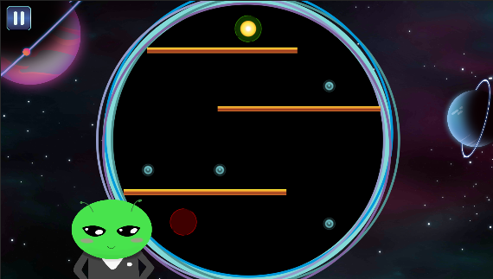

# Enemies

## Red Alien

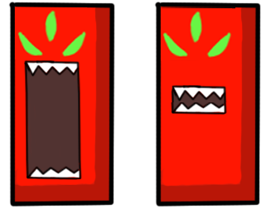

The Red Alien moves around the map in simple movements in just one direction (horizontally, vertically or diagonally). If the ball touches it, it eats the ball and its game over.

## Bomb

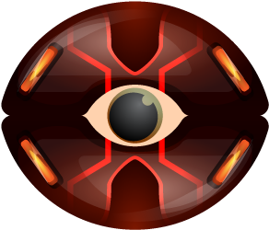

The bomb doesn’t move. It always stays at the same place. But, if the player touches it, it explodes and its game over.

# Obstacles

## Wall-less bridge

C:\Users\USER\Documents\GitHub\GravityMaze\GravityMaze\Assets\Assets\Sprites\Background\bridge.png

The Wall-less bridge can be used by the player to go from one side of the map to the other. If the yellow ball gets too close to the border, it will fall in the space and its game over.

# Maps

## Level 1

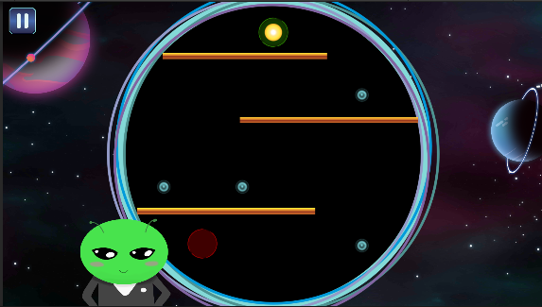

It’s a simple level made just to know the movements and the game. Doesn’t have enemies nor any real maze difficulty. It starts with a simple tutorial about how to hold the phone.

## Level 2

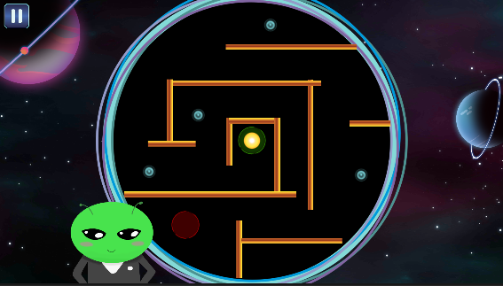

Slight difficulty increase in the maze format

## Level 3

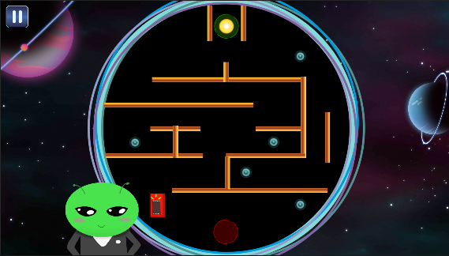

Now, we have one single enemy. Levels 3 though 5 explore the usages of the red alien.

## Level 4

## Level 5

## Level 6

## Level 7

## Level 8

## Level 9

## Level 10

## Level 11

## Level 12

## Level 13

## Level 14

## Level 15